Write a hive UDAF to find the largest integer in a column. Use your own dataset for the above problem statement and attach the steps performed, codes used with the result.

**Input:**

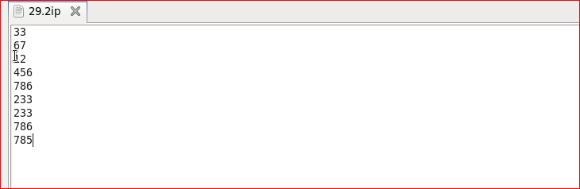

**Program:**

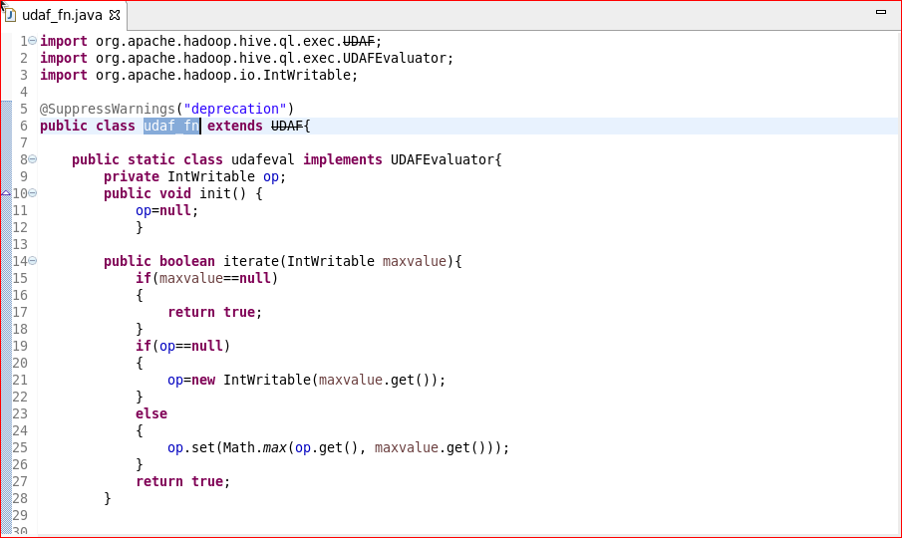

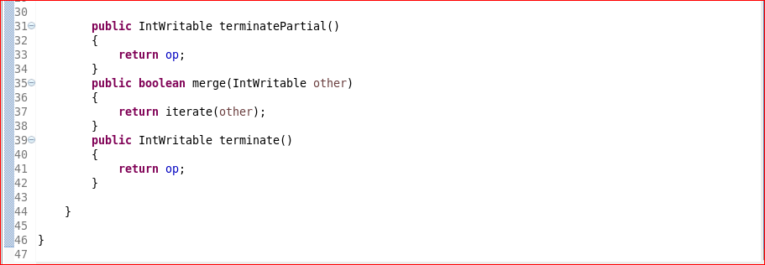

**Output:**

